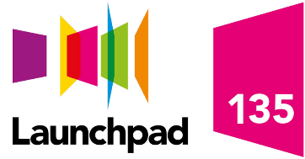

Launchpad 135 self-referral form

Please email your completed form to us at 135@launchpadreading.org.uk or you can drop it into our office. You can find us at: 135 Cardiff Road, Reading, RG1 8JF.

If you need help with this form, please email us, or call us on 0118 929 1135. Once we have a completed form we will aim to reply within 5 workings days.

You need to be over 18 to take part in a Launchpad 135 activity. If we cannot help you directly, we will try and find alternative training opportunities for you.

Name:

Date of Birth:

Post code:

E-mail address:

Phone number:

Can we contact you? | By phone By email
Are you supported by any local agencies? | For example, Job Centre+ | Fedcap | CGL | Probation  If yes, please tell us their name:
If you are, who is your contact? | Name | Email (if you know it) | Phone (if you know it)
What would you like to do or achieve at Launchpad 135?

Additional Information
Is there anything else you’d like to tell us?

Launchpad is a registered charity (279859) and is a company limited by guarantee (1459149) in England and Wales.

